.

SCHOOL OF INFORMATICS & IT

Group 1 – Proposal and Documentation:
Continuous AI Threat Exposure
and Management

Student Name (Matric Number) : Isaac Tan 2100902B

Tutorial Group : P01

Tutor : Mr. Simon Chan

Submission Date : 03 December 2023

Declaration of Originality

I am the originator of this work and I have appropriately acknowledged all other original sources used as my references for this work.

I understand that Plagiarism is the act of taking and using the whole or any part of another person’s work, including work generated by AI, and presenting it as my own.

I understand that Plagiarism is an academic offence and if I am found to have committed or abetted the offence of plagiarism in relation to this submitted work, disciplinary action will be enforced.

Note to Tutor: This page is only to be used if your subject specifically allows
AI-generated content to be used. Please delete this page if it is not required.

Declaration on the use of Generative AI tools for assignments

- Describe how you have used Generative AI tools such as ChatGPT or Dall.E-2 in your assignment.

- Show snapshots of the conversations with the AI tool (i.e., the prompts you used and the response you get from the AI tool).

How do you indicate the reference?
The content generated by AI tools are not retrievable except by the user who generated them, so they are considered non-recoverable sources. Although non-recoverable data or quotations in APA Style papers are usually cited as personal communications, with ChatGPT-generated text there is no person communicating. Quoting text from ChatGPT chat is therefore more like sharing the output of an algorithm, with a reference list entry and the corresponding in-text citation.
According to the official APA Style site, ChatGPT references should be cited as:

For example,
OpenAI. (2023). ChatGPT (Sep 25 version) [Large language model]. https://chat.openai.com/chat

Important Note:

- Do not copy answers produced by the AI tool in totality as it is considered as plagiarism.

- Do not rely on any information produced by the AI tool blindly. You should always verify the answer with other sources. Do not assume that these answers provided by the AI tool are correct.

- To achieve quality outputs from the AI tool, you should provide good prompt that is clear and specific. Be precise and provide context. Avoid asking open-ended questions.

Introduction

Emerging Cybersecurity Trends
The increasing number of AI generated threats targeting small and medium-sized enterprises (SMEs) is one of the emerging cybersecurity trends that has appeared (Lee, 2023).
With the increasing complexity of AI cyber threats and the inability to afford costly solutions (Lake, 2022), this will pose a significant increase in the risk of compromising data confidentiality, integrity, and availability. This can negatively impact the company valuation of SMEs and displace the level of trust between them and their customers.
According to a Check Point research, covered by an Infosecurity Magazine article, it shows a global 8% increase in weekly cyber-attacks during the second quarter of 2023. In which, the report focused attention on disruptive cyber-attacks using AI-enabled USB devices and a worrying increase in ransomware groups. For example, the Lockbit ransomware group has ransomed 20% more victims than last year (Mascellino, 2023).
One of the concerning aspects of AI-generated threats and AI-enabled attacks is that the rate of development by threat actors are the same or at times faster than enterprise technologies. This will be challenging for enterprises as it enables harder to predict and to detect attacks when using conventional security monitoring and enforcement approaches (Pratt, 2023). Conventional security monitoring that depends on known signatures of malware will be ineffective against unknown zero-day and unique threats. Considering that samples of unique malware can be quickly generated at a significant rate, the ineffectiveness of conventional security monitoring will only be more prevalent (SentinelOne, 2021).
Threat actors are also using AI to enhance their TTPs (Tactics, Techniques and Procedures) and improve their chances of success. An example of this would be threat actors using AI-generated phishing emails that are harder to detect by humans, as the emails do not contain any punctuation or grammar mistakes. Those of which used to be an obvious sign of a phishing email (Pratt, 2023).
From the points mentioned above, we have observed a critical problem that needs to an affordable solution aiming at small and medium-sized enterprises (SMEs).

Problem Statement
Taking on the role of a SME owner, we want to secure our company against AI threats due to the recent increase of AI malware and ransomware, which can result in compromisation of our data’s confidentiality, integrity, and availability. However, we need a financially affordable solution that can be deployed with a tight budget while not compromising on security and user experience, as we are unfamiliar with cybersecurity. This makes us worried that we cannot find a solution to properly secure our company from such threats.

Product Solution
To create a Continuous AI Threat Exposure Management (CATEMAN) software that provides:
- An affordable pay-as-you-go pricing model for SMEs, and subscription pricing tiers
for larger enterprises is our solution to the problem
- A straightforward and intuitive user interface design for ease of use
- A goal to mitigate AI-generated and AI-enabled threats

Mini-Problem Statement
“I want to create and deploy a simple dynamic website to act as the dashboard for the product quickly and easily.”

Work Distribution
Name | Work Area | Allocated Work
Isaac | Web Development | AI research and implementation, Web development
Usman |  | Web development, tier pricing research
Zikry | ML Development | AI research and implementation, tier pricing research
Daryl |  | AI research, feature research and implementation

Invention’s Relevancy to Cybersecurity
The luxury of automated and continuous threat monitoring, detection and response reduces the need for manual checks and audits when an incident occurs. For humans, many factors come into play when making the next appropriate response such as hesitations in making tough decisions, numerous roadblocks, and even human errors when an actual breach happens on-site. Hence, this results in a longer reaction time and longer time to resolve the issue.

Targeting AI-Generated & AI-Enabled Threats
Although it is crucial for companies and organisations to implement a continuous threat exposure management system, but when uniquely AI-generated attacks and threats and data breaches are on the rise, traditional systems will not be very effective. In this day and age of AI and Machine Learning (ML), our solution integrates ML with traditional applications of threat exposure to prevent these types of attacks.

Intuitive User Interface
As cyber security can be easily overlooked by SMEs that can lead to a false sense of security, we want to implement an intuitive user interface that easily grabs the user’s attention to discover what we can offer.
With minimal scrolling and clicking, we aim to be transparent with our description and subscription plans. For example, some products offer a demo to the customer first before announcing the price. However, we prefer a more direct approach, where we placed the price button in the top navigation bar. After reading a short description and features of what our product has to offer in the home page, users will see that the price button is conveniently placed above in the same page and can immediately navigate to view our pricing models.
Furthermore, we have neatly consolidated information into tables for existing users to view their alerts and risks in the dashboard. Since it is necessary to assume that not every customer is well-equipped with basic IT or cybersecurity knowledge, our classification of the data and statistics of the alerts are labelled with simple keywords for users to well understand and grasp the relevant information and the associated level of risk.

Data Classification Diagram

Web Application Data
Public | Restricted
Company email/hotline/address  - Visible to the public for any personal enquiries | Customer login information  - Able to view company’s dashboard logs and information and unsubscribe or stop all services
Price tier list  - Visible to the public to view the pricing to know which is best suited for their company | Credit card information  - Steal customer’s credit card information for attacker’s financial gain
Dashboard information
- Attacker can gather information about company’s assets
CATEMAN Admin login information
- Attacker able to gain access to all data and services

Use & Misuse Case Diagram

Use Case 1 : New Customer
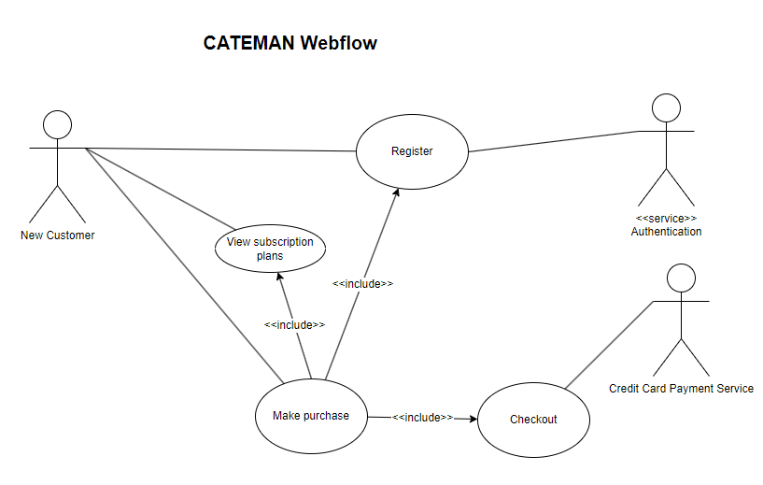
Description: Use case for new customers to register, view CATEMAN’s subscription plans and making payment.
Actors: New Customer, Authentication, and Credit Card Payment Service
Triggers: User must first register a new account.
Pre-conditions:
- To make a purchase, the customer must view the subscription plans.
- Then, the customer registers a new account to make a purchase.
Basic-flows: The customer will first view the subscription plans. Before making payment, new user must create a new account first.

Use Case 2: Existing Customer
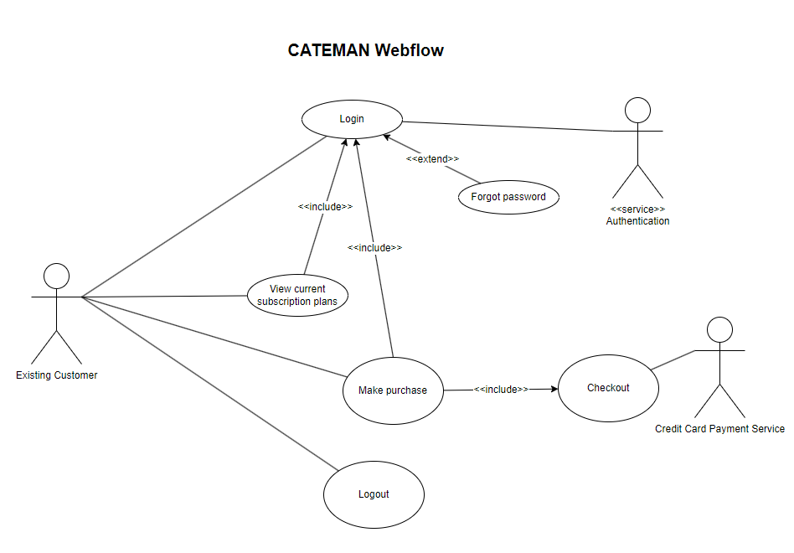
Description: Use case for existing users to either view their current subscription plans, or to make a purchase if they have not already done so.
Actors: Existing Customer, Authentication, Credit Card Payment Service
Triggers: Customer must first login.
Pre-conditions:
- To view the user’s current subscription plans, the user must first login to the account.
- To make a purchase, the user must first login to the account.
Basic-Flows: An existing user logs in to view his current subscription plan. A user can have an existing account but have yet to make a purchase can still do so, following the same flow as Use Case 1 in making a purchase.

Use Case 3: Alert Dashboard
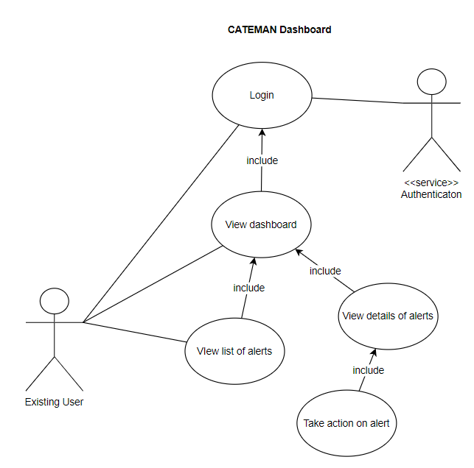
Description: Use case for logged in users to view the main dashboard, list of alerts and to take action on alerts
Actors: Existing Customer
Triggers: Customer must first login.
Pre-conditions:
- To view the dashboard with the alerts, the user must login to the account.
- To act on the alerts, the user must view the list of alerts from the dashboard.
Basic-Flows: An existing user log in to the system and view the dashboard with the summary of alerts. The user can view the list and details of alerts and take appropriate action on the alert listed.

Use Case 4: Client Admin
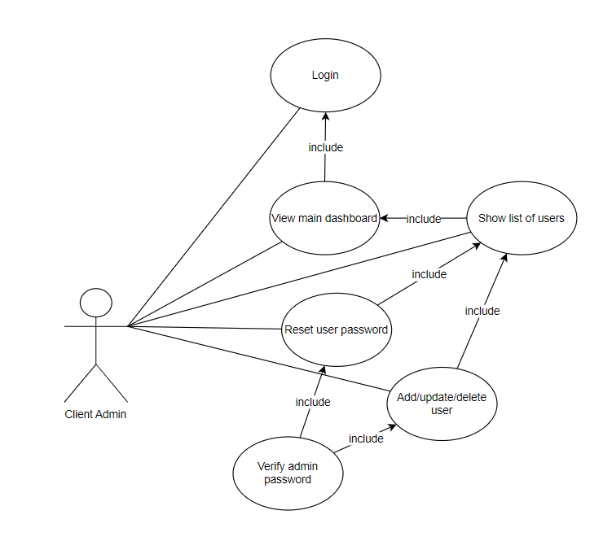
Description: Use case for client admin to add/modify/delete user, reset password for user.
Actors: Client admin
Triggers: Customer must first login.
Pre-conditions:
- The client admin must login to the system to view the user list under his company.
Basic-Flows: A client admin log in to the system and view the users details under his company. The client admin can add new user, update existing user details, delete existing user, or reset password for the existing user from the users dashboard in the system.

Misuse Case 1: Stealing Login Credentials
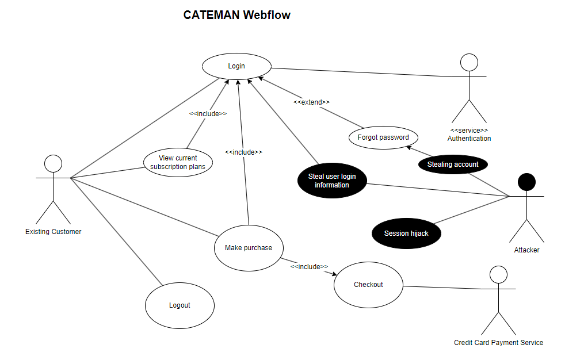
Description: Use case for 3 possible threats that may occur in the process of logging into an existing user account.
Actors: Existing Customer, Authentication, Attacker
Pre-conditions: Existing customer will first login to view the current plan or access the dashboard.
Triggers & Basic-flows:
- Performing man in the middle attack when existing customer login or does “forgot password” action and is needed to provide some user information to change password.
- Attacker can hijack the user’s session to cancel subscription and stop all CATEMAN services from running.

Misuse Case 2: Stealing Credit Card Information/Modifying Plan
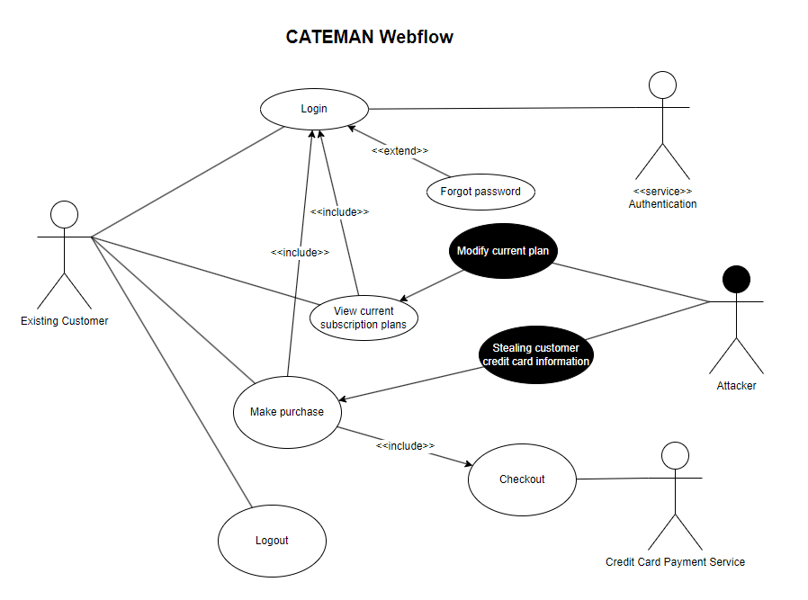
Description: Use case of 2 possible threats that might occur when the customer is making a purchase or when the user is logged in.
Actors: Existing Customer, Credit Card Payment Service, Attacker
Pre-conditions:
- Existing customer will first login to view current plans and change subscription plan if necessary.
- A newly created user will be logged in to choose a plan and make payment.
Triggers & Basic-flows:
- The attacker can change the customer’s current subscription plan to a more expensive one after stealing the login credentials or through session hijacking.
- The attacker performs a man in the middle attack when customer is making a purchase to steal the customer’s credit card credentials.

Misuse Case 3: Accessing company asset details
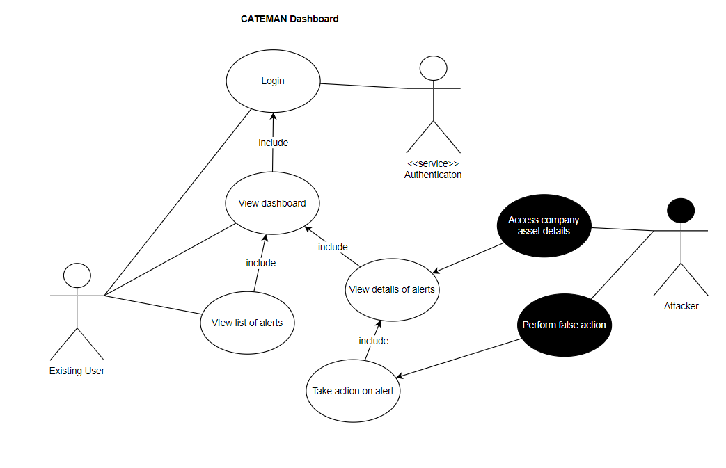
Description: Use case for possible threat while the user is accessing the alert details.
Actors: Existing Customer, Attacker
Pre-conditions:
- To view the dashboard with the alerts, the user must login to the account.
- To act on the alerts, the user must view the list of alerts from the dashboard.
Triggers & Basic-Flows:
- Attacker can gain access to the company asset details from the alert list after stealing login information.
- Attacker can perform false action on the alert and keep the vulnerability detected open to exploit.

Misuse Case 4: Restrict access of users / add or delete users.
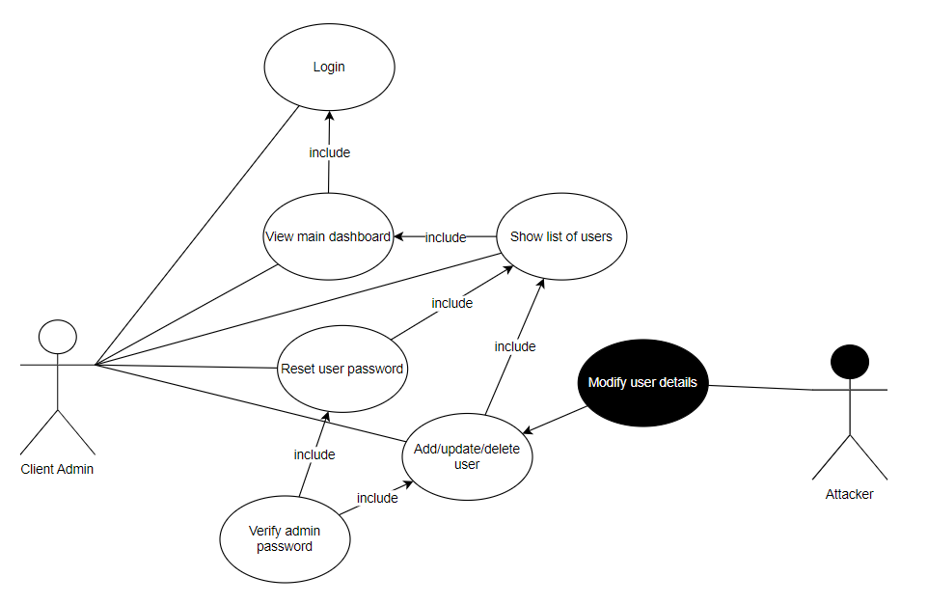
Description: Use case for possible threats when a client admin performs add/modify/delete operations for a user or reset password for user.
Actors: Client admin, Attacker
Pre-conditions:
- The client admin must login to the system to view the user list under his company.
Triggers & Basic-Flows:
- After stealing the login information of a client admin, attacker can reset password for other users to restrict their login or add/modify/delete the user.
- Attacker can access all the user’s details of the company.

Experience As an Inventor
Creativity and innovation are not my strongest suits, not until when I first created my very own working restaurant review website in Year 1.2. Coming into this module, I had no expectations and was dreadful even when I knew that I had to create and design a fully functioning website. I also have no artistic skills, let alone designing a website in code. It was traumatising and overwhelming at first, considering I must produce a full stack website from scratch.
After countless hours of practice and learning 4 new languages (HTML, JS, CSS, SQL), I was slowly getting the hang of it. There were many factors coming into play when making my own website, such as the colour scheme, the layout of my items, where the buttons are placed, and many more. I had to do countless hours of research of different websites, colour schemes, and finding a website for an inspiration for my own website. Then, I had to make a wireframe to visualise how I want the website to look like, and what features and functions I want to implement to improve user experience and to stand out more. I also had the help of my lecturer who was always willing to help me, be it debugging or clarifying my doubts, and even explaining to me the concepts of using colours in designing. From there, I continued researching about the use of different colours in websites and how it affects user experience. There were also a few future enhancements that I had to include as I did not have enough time to implement them, such as a filter and search feature. I put a lot of thought into it as I really wanted my work to be unique and most importantly to be satisfied with it in the end.
Towards the end, I started seeing fruitful results from my hard work and slowly realised that everything I was seeing on the website was created based on my creativity and seeing everything come together and working on the website was very fulfilling.
Finally, when presenting my website, I was proud of my work and was happy to present it to my lecturer. He complimented that he liked the layout of my website, the colour scheme chosen and the simplicity of it. After the presentation, it occurred to me that innovation does not have to mean creating something complex or complicated. There are currently many complex but impressive websites with different CSS animation styles or even an animated background that developers are doing. In the end, the simplicity of the product, or in this case, the website, is much preferred.

Commercial Feasibility

Machine Learning Model
The ML model used for the prototype is an open-source model named bart-large by Hugging Face and it is trained using a Multi-Genre Natural Language Inference (MultiNLI) dataset.

System Infrastructure
The current system infrastructure plan is to set up the CATEMAN software on Amazon Web Services as they provide various types of elastic computing resources that we can easily and quickly prep for machine learning.
The reasoning for this is so that the software engineers do not have to spend a significant amount of time setting up the infrastructure. This allows them to focus more on the development of our very own Text Inferential Machine Learning model, which brings us to the next point.

Operating System
The operating system that we will be using is Ubuntu Pro as it will be the most cost effective and preferred, over the alternative being Windows because of its proprietary nature (OpenMetal, 2023). However, a significant security hardening will be required to be configured before any development can be done on the system as Ubuntu Pro (a distribution of Linux) is an open source operating system more prone to security compromises. Hence, this action will reduce the risk of this vulnerability.

Instance Type
The AWS Elastic Cloud Computing (EC2) instance type CATEMAN will be using will be type G5g, which is best used for inferential deep machine learning models for natural language processing.
The G5g instance type features:
- Custom built AWS Graviton2 Processor with 64-bit Arm Neoverse cores
- Up to 2 NVIDIA T4G Tensor Core GPUs
- Up to 25 Gbps of networking bandwidth
- EBS-optimized by default
- Powered by the AWS Nitro System, a combination of dedicated hardware and lightweight hypervisor

Instance Size
Regarding the G5g instance size, the g5g.2xlarge will be selected as it includes 16 GiB of memory and 8 virtual CPU cores and up to 10 Gigabit in terms of network performance.

Instance Operational Costs
Considering the G5 instance type with the g5g.2xlarge size, it operates at $0.792 per hour, which is approximately $35,000 for the 5 years. When including the approximate operational costs of $12,500 for 5 years, the total cost for the Machine Learning ops will be $47,500 for 5 years.

Web Hosting
The product will be deployed and hosted through AWS Elastic Beanstalk. It is a very quick and easy service to deploy applications in the AWS cloud and offers flexibility in managing the AWS infrastructure (AWS, 2023), since we are incorporating the use of AWS EC2 instances as well.

Operational Costs
The cost needed of running the EC2 instances and any other services running alongside the instances will equate to roughly $30 to $100 a month, with low to medium traffic. Hence, for 5 years, it would cost average of $4,200 to host the CATEMAN website on AWS.

Data Storage

Operational Costs
The cost to store data in DynamoDB will grow as CATEMAN gains more customers, and effectively more assets to monitor. Additionally, if data is planned to be stored in a Relational Database Service (RDS), it will cost significantly more. The cost can approximately be $5 to $65 per month, which equates to an average of $2,100 in 5 years. Naturally, the more data we store as our number of clients increases, the cost to store their data will increase.

Return Of Investment
Considering that a SME client with 100 employees, each with a work device to secure, uses CATEMAN, that will equate to $2500 per month and $30,000 in a year. In 5 years, we will generate $150,000 from this one SME client.
Taking into account the cost of the Machine Learning Operations, Web Hosting and Data Storage, the total approximate operational cost of CATEMAN is $53,800. Deducting this amount and half of the remaining, for CATEMAN’s future enhancement investments, from our revenue generated from that one SME client example, leaves us with a little less than $50,000 in terms of profit.

Future Enhancements

Standalone System Infrastructure
With enough profit and revenue from our product, we intend to deploy our ML operations, research and development (R&D) infrastructure on our standalone infrastructure, independent from any cloud provider, while our website remains to be hosted on AWS.
As the prototype of CATEMAN utilises an open-sourced, pretrained Machine Learning Language Inference model, continuously researching and developing our own ML model and trained with the right. At that point, it will also be beneficial to keep that technology confidential. Hence, the rationale behind of deploying ML operations and R&D to our private systems.

Higher ML Accuracy
Since CATEMAN uses a open-source model that is not specifically developed to detect or mitigate AI threats, we are planning to research and develop our own CATEMAN ML model. The model will be designed to detect AI-generated content to detect AI-generated phishing emails and better detect suspicious activity from log analysis. We will also curate our own collections of datasets, such as a compilation of known malware and malicious domains from extensive searching on the Internet. Using this dataset, it will significantly improve the accuracy of our future CATEMAN ML model.

Hybrid Malware Analysis
Currently, CATEMAN only conducts static analysis on executables of potential malware. We intend to further develop this into a hybrid malware analysis framework, where dynamic analysis will be implemented to produce the behavioural data in a sandboxed environment. Additionally, static and reputational analysis will be conducted on the behavioural data to determine the intent of the executable. If intent is malicious, the CATEMAN ML Model will be taught to label that executable as malicious.
Additionally, we will also be developing a user and entity behaviour analysis (UEBA) upon the development of the hybrid malware analysis as the UEBA is reliant on the dynamic malware analysis.

Integrated AI and Web Application
A crucial future enhancement is to integrate the AI into the web application for it to serve as a product fully. We will be creating an API that connects the AI, database, and the website together, where the generated data and information from the AI will be displayed in the website’s dashboard.

Website Feature Enhancements
Since this website is only a prototype to deploy with the AI for the time being, we already have several future website implementations ideas in mind. For example, some basic features include a user registration page, a credit card payment page, and an unsubscribe button to cancel subscription, which will stop all CATEMAN services running on their assets.
To understand our customers better, we also intend to collect data and information of their company’s needs by creating a short questionnaire per sign up that asks about their company sizes and an estimated size of logs they may have for the AI to analyse. This will be beneficial for us to understand better our target audiences’ needs, and to make future improvements like adding new features to our product that cater to them.
When a new customer subscribes to a plan on our website, we are planning to automate the backend to:
- create new database and tables for the company
- download current user login details of DevAdmin from CATEMAN main database
- insert the DevAdmin data into the users table to give access to the CATEMAN developers in the new database.

Potential Market Opportunity

Affordable Pricing Model
With the target clientele of SMEs and start-up companies in mind, which do not have a significant budget to spend on cyber security measures and monitoring, we decided to develop a pay-as-you-use pricing model. This means that the enterprise will only pay per the number of employees they employ, until the enterprise is considered a large enterprise, in which they will switch to a monthly subscription but still at an affordable price.

Bundle Pricing
For micro and smaller enterprises, we are proposing $25/asset, where the company has less than 200 assets. For medium enterprises, we are proposing $20/asset, where the company has between 200-500 assets.
There can be cases where startups begin with only 2 employees (boss and employee), and the least number of endpoint devices required are 3 (2 laptops and 1 server). Hence, we have decided to offer a starting bundle subscription plan of $65 for the price of 4 assets, and any extra assets after that for $25/asset.
Though the bundle may seem to require certain companies with 2 employees to pay for an extra asset, this bundle presents a much affordable option than paying for 3 assets for the price of $75. In time, the company will grow and there will be another asset filling in the bundle, making it more affordable and worth overall.

Target Customers
We will start with SMEs and startup enterprise clients within Singapore to ensure that we can enforce data compliance in Singapore before expanding to other countries. We plan to target customers in the ASEAN region so that we can build up momentum when it comes to handling different data compliances and computer laws in other countries.

Conclusion
In conclusion, CATEMAN serves as a very affordable AI monitoring and threat detection system for small enterprises. Comprising of phishing email detection, network monitoring analysis, malware analysis, and user behavioural analysis, it allows companies to get a quick start into having a strong security foundation. Placing it at a very cheap and affordable price is our unique selling point and would be tough for new customers to overlook our product and miss out the services we can offer.
Furthermore, our plan for future enhancements emphasises our passion to cater to the needs of our SME target audiences, to continue coming up with new features and improvements to our product for them. Lastly, our intuitive dashboard user interface contributes greatly to the overall user experience in aiding users to understand well of the list of alerts and details shown.

Reflection
These 8 weeks has been insightful for me as I was working together with my group to create an AI that can detect phishing emails. As students who are not trained in AI, there was indeed tons of research that went into this, such as gathering many datasets, source codes, and hunting for trained models for phishing email detection to aid us in making our version of the AI.
However, the innovative part was our main weakness and spent the most time thinking as there are already huge companies like IBM who have already created such advanced AI and many other features and services. We truly had to be innovative and think of ways to be different from these existing companies, and at the same time to not have our solution be too complicated and complex. I was fortunate to be working in a group where we can all brainstorm ideas and have fruitful discussions before finalising on one idea, CATEMAN.
I was very scared when we finalised the decision of making an AI as I have seen how even the simplest AI like differentiating a cat and a dog is created, and the amount of research and datasets required in making one. Not to mention the accuracy, errors, and constant need to improve the ML.
Though I am mainly working on the website part of the project, I still wanted to be more involved in the AI development as I was also genuinely curious in the process of making one. Making an AI from scratch in this short time was truly impossible, considering we are not students of AI. Hence, we had to use pre-trained models and public datasets for our ML to learn, which also gives rise to inaccurate results. In the end, despite the inaccurate results, we created a phishing email detection AI.
I learned a lot about making an AI from this project, and learning the different marketing strategies for our product to profit in the market truly has been insightful.

References
AWS. (2023). What is AWS Elastic Beanstalk? https://docs.aws.amazon.com/elasticbeanstalk/latest/dg/Welcome.html
Lake, K. (2022, October 20). Top SME Cybersecurity Challenges and How to Overcome Them. Jumpcloud. https://jumpcloud.com/blog/overcome-top-sme-cybersecurity-challenges
Lee, S. (2023, November 7). No business too small: ransomware’s growing appetite for SMEs. SMEhorizon. https://www.smehorizon.com/no-business-too-small-ransomwares-growing-appetite-for-smes/
Mascellino, A. (2023, August 23). Artificial Intelligence and USBs Drive 8% Rise in Cyber-Attacks. Infosecurity Magazine. https://www.infosecurity-magazine.com/news/ai-usbs-drive-rise-cyber-attacks/
OpenMetal. (2023, October 30). Machine Learning and Operating Systems. https://openmetal.io/docs/product-guides/private-cloud/machine-learning-and-operating-systems/
Pratt, M. K. (2023, September 7). Emerging cyber threats in 2023 from AI to quantum to data poisoning. CSO. https://www.csoonline.com/article/651125/emerging-cyber-threats-in-2023-from-ai-to-quantum-to-data-poisoning.html
SentinelOne. (2021, August 12). What Is A Malware File Signature (And How Does It Work)? https://www.sentinelone.com/blog/what-is-a-malware-file-signature-and-how-does-it-work/

